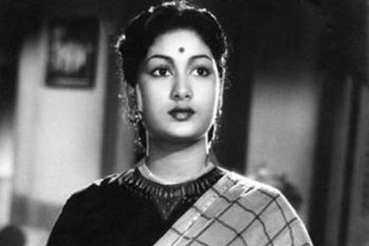

**FIVE**

Issue

*The lady tiger*

***in this issue >>>***

*Making a good first impression counts!*

*Savitri is a best actress we ever seen. Her acting cannot be replaced by any one…she is most generous person*

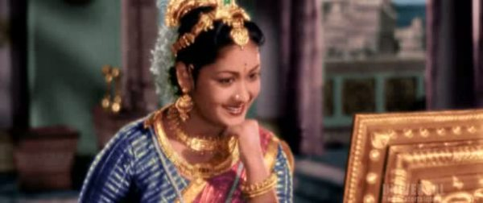

n a career spanning three decades, Savitri appeared in more than 250 films. Her first significant role was in the 1952 film Pelli Chesi Choodu. Later, she starred in several critically acclaimed and commercially successful films, including Devadasu (1953), Missamma (1955), Ardhangi (1955), Donga Ramudu (1955), Thodi Kodallu (1957), Mayabazar (1957), Mangalya Balam (1959), Aradhana (1962), Gundamma Katha (1962), Nartanasala (1963),[1] Doctor Chakravarty (1964), Sumangali (1965), and Devata (1965).[2]

Savitri was also known for her philanthropic work and generosity towards the poor. In recognition of her contributions to Indian cinema, she received the "A Moon Among Stars" honor at the 30th International Film Festival of India in 1999.[3] Her life and career were later depicted in the biographical film Mahanati (2018), which won the "Equality in Cinema Award" at the Indian Film Festival of Melbourne.

Savitri acted in dance dramas as a child, including some work with a theatre company run by Jaggayya. She made an unsuccessful speculative trip to find film work in Madras at the age of 14 when she was deemed to be too young to play heroine roles, but in 1950 was cast as the female lead in Samsaram (1950). That role did not become actuality because she became too excited, necessitating numerous retakes and eventually her replacement in the part. She was given a minor speaking role in the film and in the next year had two more minor roles, in Roopavati and Pathala Bhairavi (both in 1951), before getting her big break as the second heroine in Pelli Chesi Choodu (1952). She, later on, was propelled to stardom with critically acclaimed roles in blockbusters such as Devadasu (1953),[9][10][11] and Missamma (1955).[6]

*Nissankara Savitri (also known as Savitri Ganesan; 6 December 1934[a] – 26 December 1981) was an Indian actress and filmmaker who predominantly worked in Telugu and Tamil films. Widely regarded as one of the greatest actresses in the history of Indian cinema, she was popularly known by the epithets Mahanati (transl. The great actress) in Telugu and Nadigaiyar Thilagam (transl. Doyen of all the actresses) in Tamil. Savitri was among the highest-paid and most sought-after actresses in South Indian cinema during the 1950s and 1960s.*

**Mayabazar, gundamma katha,missamma…..**

***SAVITHRI***

***set the stage >>>***

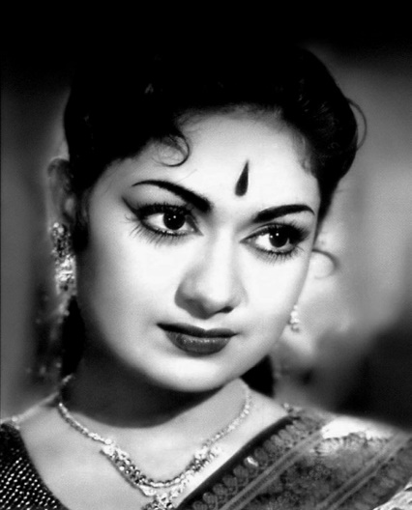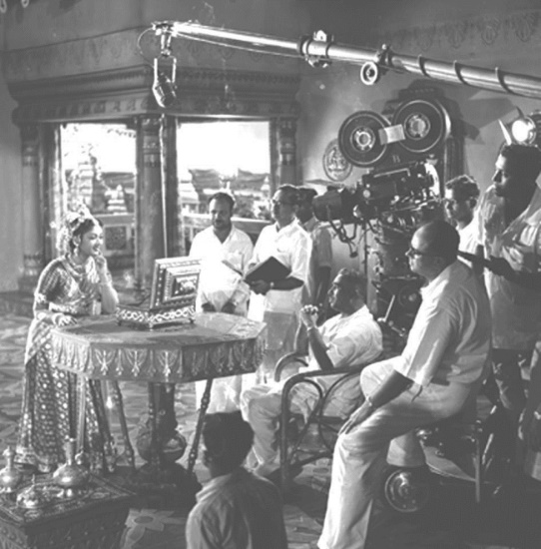

*On Sets!*

Director P. Chandrasekhara Reddy who directed Savitri says, "there is none who can equal her beauty and talent. She didn't heed anyone's advice and got married very early. I remember she was so addicted to drinking even on the sets; she threw up on my shirt during a shoot. The next day she got a brand new shirt for me. She was a generous woman." Savitri also worked in Bollywood films, although she did not find much success.[6] She also acted in three Malayalam films notably Chuzhi (1973).[12]

Savitri on the sets of Mayabazar

Her performance in the 1957 film Mayabazar skyrocketed her to stardom. She later went on to become the highest-paid and most sought-after South-Indian actress of her generation. Savitri was known for her hospitality, philanthropic gestures, and love of buying property and jewelry, but she kept little control of her spending. Ganesan continued to philander and she was susceptible to favoring hangers-on with her largesse. In 1960, she received special mention from Rashtrapathi for her performance in the Telugu film Chivaraku Migiledi. In 1963, she starred in Nartanasala (1963), featured at the Afro-Asian Film Festival in Jakarta.[1] In 1968, she produced and directed the Telugu film Chinnari Papalu, for which she received the state Nandi Award for Best Feature Film(Silver). Her career took a downturn in the late 1960s. Her properties were seized by tax officials in the 1970s and she turned to act in any film in her later years, while sycophants encouraged her to direct and produce films that were unsuccessful and financially draining. Among her few supporters during her financial troubles were Dasari Narayana Rao, who cast her in most of his films, such as Gorintaku (1979), and specifically made Devadasu Malli Puttadu (1978) as a movie for her.[13]

Savitri was also one of the top Tamil actresses of her era. She acted with major stalwarts, such as M.G.R, Sivaji Ganesan and mostly with her husband Gemini Ganesan. Her notable Tamil works include Kalathur Kannamma (1959), Pasamalar (1961), Pava Mannippu (1961), Paarthal Pasi Theerum (1962), Karpagam (1963), Karnan (1963), Kai Koduttha Dheivam, Navarathri (1964), and Thiruvilaiyadal (1965).

In 1958 Savitri was booked by M. G. Ramachandran for his second directorial venture Ponniyin Selvan.[14] One of the first screen adaptations of Kalki Krishnamurthy's Ponniyin Selvan, the film had a huge ensemble cast consisting of Vyjayanthimala, Padmini, Gemini Ganesan, Saroja Devi, M. N. Rajam and Nagesh.[15] In the film, she was given the role of Poonguzhali and the wife of Senthan Amuthan.[15] However, in mid-1958 the film was shelved for unknown reasons.[16]

Director P. Chandrasekhara Reddy who directed Savitri says, "there is none who can equal her beauty and talent. She didn't heed anyone's advice and got married very early. I remember she was so addicted to drinking even on the sets; she threw up on my shirt during a shoot. The next day she got a brand new shirt for me. She was a generous woman." Savitri also worked in Bollywood films, although she did not find much success.[6] She also acted in three Malayalam films notably Chuzhi (1973).[12]

Savitri on the sets of Mayabazar

Her performance in the 1957 film Mayabazar skyrocketed her to stardom. She later went on to become the highest-paid and most sought-after South-Indian actress of her generation. Savitri was known for her hospitality, philanthropic gestures, and love of buying property and jewelry, but she kept little control of her spending. Ganesan continued to philander and she was susceptible to favoring hangers-on with her largesse. In 1960, she received special mention from Rashtrapathi for her performance in the Telugu film Chivaraku Migiledi. In 1963, she starred in Nartanasala (1963), featured at the Afro-Asian Film Festival in Jakarta.[1] In 1968, she produced and directed the Telugu film Chinnari Papalu, for which she received the state Nandi Award for Best Feature Film(Silver). Her career took a downturn in the late 1960s. Her properties were seized by tax officials in the 1970s and she turned to act in any film in her later years, while sycophants encouraged her to direct and produce films that were unsuccessful and financially draining. Among her few supporters during her financial troubles were Dasari Narayana Rao, who cast her in most of his films, such as Gorintaku (1979), and specifically made Devadasu Malli Puttadu (1978) as a movie for her.[13]

Savitri was also one of the top Tamil actresses of her era. She acted with major stalwarts, such as M.G.R, Sivaji Ganesan and mostly with her husband Gemini Ganesan. Her notable Tamil works include Kalathur Kannamma (1959), Pasamalar (1961), Pava Mannippu (1961), Paarthal Pasi Theerum (1962), Karpagam (1963), Karnan (1963), Kai Koduttha Dheivam, Navarathri (1964), and Thiruvilaiyadal (1965).

In 1958 Savitri was booked by M. G. Ramachandran for his second directorial venture Ponniyin Selvan.[14] One of the first screen adaptations of Kalki Krishnamurthy's Ponniyin Selvan, the film had a huge ensemble cast consisting of Vyjayanthimala, Padmini, Gemini Ganesan, Saroja Devi, M. N. Rajam and Nagesh.[15] In the film, she was given the role of Poonguzhali and the wife of Senthan Amuthan.[15] However, in mid-1958 the film was shelved for unknown reasons.[16]

Sivaji Ganesan and mostly with her husband Gemini Ganesan. Her notable Tamil works include [*Kalathur Kannamma*](https://en.wikipedia.org/wiki/Kalathur_Kannamma) (1959), [*Pasamalar*](https://en.wikipedia.org/wiki/Pasamalar) (1961), [*Pava Mannippu*](https://en.wikipedia.org/wiki/Pava_Mannippu) (1961), [*Paarthal Pasi Theerum*](https://en.wikipedia.org/wiki/Paarthal_Pasi_Theerum) (1962), [*Karpagam*](https://en.wikipedia.org/wiki/Karpagam) (1963), [*Karnan*](https://en.wikipedia.org/wiki/Karnan_(1964_film)) (1963), [*Kai Koduttha Dheivam*](https://en.wikipedia.org/wiki/Kai_Koduttha_Dheivam), [*Navarathri*](https://en.wikipedia.org/wiki/Navarathri_(1964_film)) (1964), and [*Thiruvilaiyadal*](https://en.wikipedia.org/wiki/Thiruvilayadal_(1965_film)) (1965).

n 1958 Savitri was booked by [M. G. Ramachandran](https://en.wikipedia.org/wiki/M._G._Ramachandran) for his second directorial venture *Ponniyin Selvan*.[[14]](https://en.wikipedia.org/wiki/Savitri_(actress)#cite_note-selvan-15) One of the first screen adaptations of [Kalki Krishnamurthy](https://en.wikipedia.org/wiki/Kalki_Krishnamurthy)'s [*Ponniyin Selvan*](https://en.wikipedia.org/wiki/Ponniyin_Selvan), the film had a huge [ensemble cast](https://en.wikipedia.org/wiki/Ensemble_cast) consisting of [Vyjayanthimala](https://en.wikipedia.org/wiki/Vyjayanthimala), [Padmini](https://en.wikipedia.org/wiki/Padmini_(actress)), [Gemini Ganesan](https://en.wikipedia.org/wiki/Gemini_Ganesan), [Saroja Devi](https://en.wikipedia.org/wiki/B._Saroja_Devi), [M. N. Rajam](https://en.wikipedia.org/wiki/M._N._Rajam) and [Nagesh](https://en.wikipedia.org/wiki/Nagesh).[[15]](https://en.wikipedia.org/wiki/Savitri_(actress)#cite_note-ponni_cast2-16) In the film, she was given the role of [Poonguzhali](https://en.wikipedia.org/wiki/Poonguzhali) and the wife of [Senthan Amuthan](https://en.wikipedia.org/wiki/Rajaraja_I).[[15]](https://en.wikipedia.org/wiki/Savitri_(actress)#cite_note-ponni_cast2-16) However, in mid-1958 the film was shelved for unknown reasons.[[16]](https://en.wikipedia.org/wiki/Savitri_(actress)#cite_note-selvan22-17)

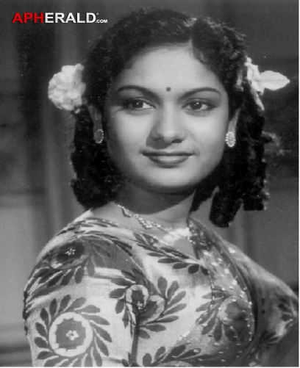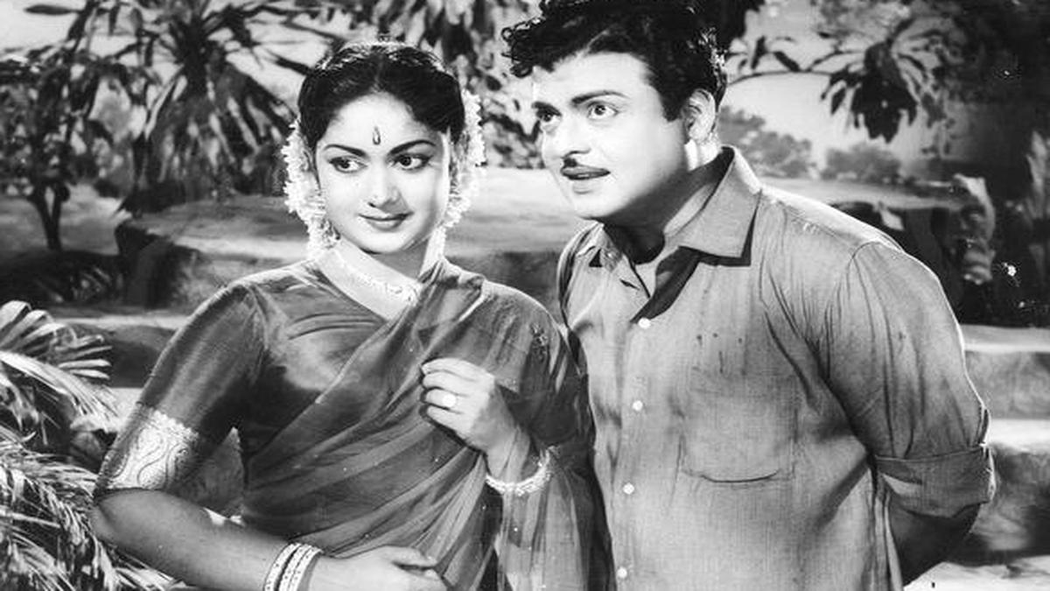

**In popular culture**

[[edit](https://en.wikipedia.org/w/index.php?title=Savitri_(actress)&action=edit&section=5)]

Savitri's biopic, titled [*Mahanati*](https://en.wikipedia.org/wiki/Mahanati), starring [Keerthy Suresh](https://en.wikipedia.org/wiki/Keerthy_Suresh) as Savitri and [Dulquer Salmaan](https://en.wikipedia.org/wiki/Dulquer_Salmaan) as [Gemini Ganesan](https://en.wikipedia.org/wiki/Gemini_Ganesan) was released in 2018 to critical acclaim and commercial success.[[19]](https://en.wikipedia.org/wiki/Savitri_(actress)#cite_note-50days-20) In the 2019 biopic film of [N.T.R.](https://en.wikipedia.org/wiki/N._T._Rama_Rao) titled [*NTR: Kathanayakudu*](https://en.wikipedia.org/wiki/NTR:_Kathanayakudu), actress [Nithya Menen](https://en.wikipedia.org/wiki/Nithya_Menen) portrayed Savitri onscreen.[[20]](https://en.wikipedia.org/wiki/Savitri_(actress)#cite_note-21)

*She acted with Sivaji Ganesan in Kai Kodutha Deivam, Amaradeepam, Karnan, Saraswathi Sabadham, Navarathri, Ellam Unkkaga, Thiruvatchelvar, Thrivalayadal, Kathavarayan, Annayin Aanai, Penin Perumai, Bandha Pasam and Ratha Thilagam.She played sister of Sivaji Ganesan in Pasamalar and Pava Manippu.*

*Savithri acted with M. G Ramachandran in Parisu, Vettaikaran and Mahadevi.*

*She acted opposite Gemini Ganesan in Poojai Ki Vandha Malar, Kathirunda Kangal, Anavin Aasai, Pasamalar, Guna Sundari, Penin Perumai, Yaar Paiyan, Padha Kanikkai, Maman Magal, Karupakarasi, Karpagam, Hello Mr. Zamindar, Iru Sahotharigal and Pava Manippu.*

*She acted with Jayalalitha in Unnai Sutrum Ulagam, Baghdad Perazhagi and Suryagandhi. Jayalalitha and Kanchana had made guest appearance in Telugu film Navagraham.*

*In popular culture*

*Savitri's biopic, titled Mahanati, starring Keerthy Suresh as Savitri and Dulquer Salmaan as Gemini Ganesan was released in 2018 to critical acclaim and commercial success.[19] In the 2019 biopic film of N.T.R. titled NTR: Kathanayakudu, actress Nithya Menen portrayed Savitri onscreen.[20]*

*\*

*Expenses to expect when buying a home*

Option congue nihil imperdiet doming id quod mazim placerat facer minim veni am ut wisienim ad minimeniam, quis erat nostr uexerci tation ullam corper nostru exerci tation ullam corper et iusto odio dig nissim qui blandit praesent lupta. Tummer delenit augue duis dolore te feugait nulla facilisi. Con erattis sectetuer adip iscing elit, sed numm.

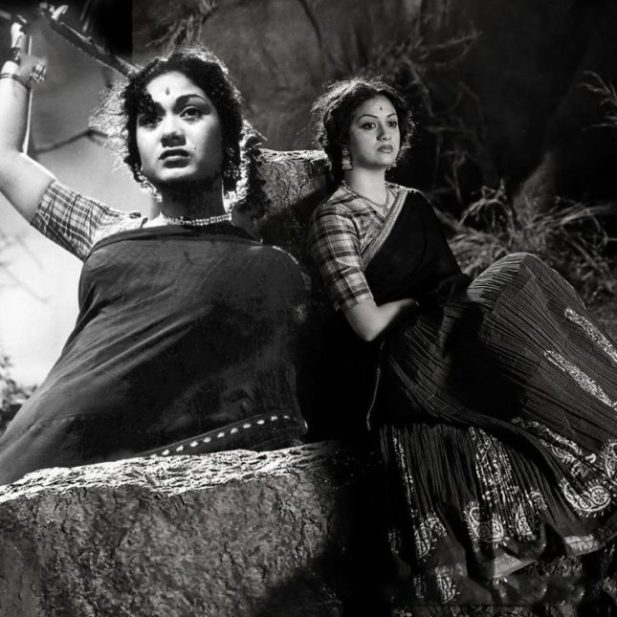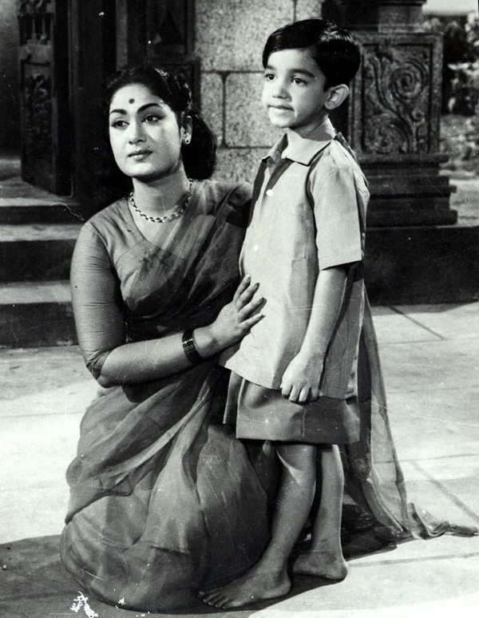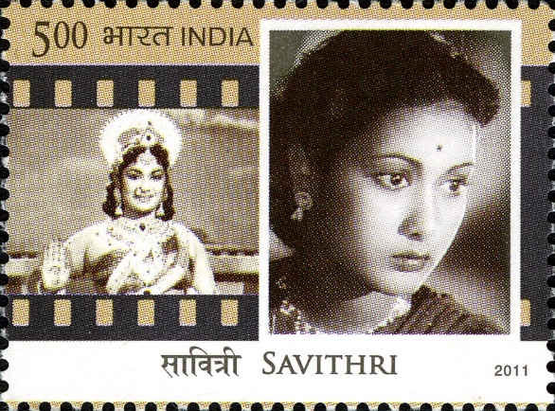[](https://www.layoutready.com/?utm_source=microsoft&utm_medium=file&utm_campaign=office_online)

*We will have about the legendary man sonusood who helped lakhs of people during pandameic.*

THE D&B NEWS

*Coming soon>>>*